# Reflection Paper In Human Resource Management Project

1. **Project Analysis**

HRM Project team analyzes 5 attributes: Size, Culture, Dynamism, Personnel, and Criticality.

* **Criticality**: Traditional methods require all/most requirements defined up front so a plan and budget can be developed. Besides, the plan for requirement phase is 22 weeks and there will be a contract between the HRM team and customers. Therefore, the traditional methodology is the best choice.
* **Size**: HRM team realized that the size of Human Resource Management project is relatively big and it will take 37 weeks for development. Therefore, traditional methodology is suitable with HRM project
* **People:** All members in HRM team are not the professor in software development, especially in design and coding. Therefore, one member cannot assume the roles at the same time. Besides, the skill in programming of team member is not good and everyone does not ready for new technology. Therefore, the traditional method is the best choice.
* **Dynamism**: In HRM project, the requirement will be baselined after 22nd week. Therefore, the customer cannot change the requirements anymore.
* **Culture:** The members in team do not want any changes. If have, all changes must be approved by Change Control Board (CCB). It means that everything must follow by the policy and procedures.

*Figure 2: Home Ground Methodology*

Therefore, based on 5 attributes to choose the methodology, HRM team decided to choose traditional method for development, and typical, this is V-Model. The V-Model represents a software development process which may be considered an extension of the waterfall model. Instead of moving down in a linear way, the process steps are bent upwards after the coding phase, to form the typical V shape. The V-Model demonstrates the relationships between each phase of the development life cycle and its associated phase of testing. And if there are defects in architect phase, it will be return in requirement phase for updating the requirements.

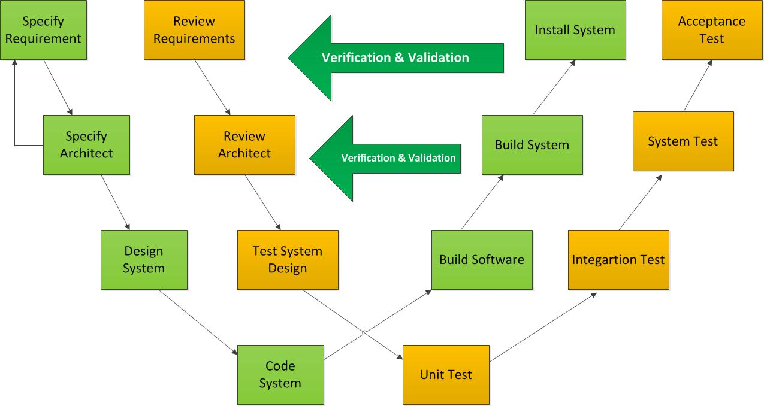

*Figure 1: The V-Model*

In Human Resource Management project (HRM), after many meetings between the members in team, everyone united to choose V-model for HRM project. There are some reasons for this decision:

1. The V-model helps to minimize the project risks by specifying standardized approaches and describing the corresponding results and responsible roles. It permits an early recognition of planning deviations and risks and improves process management, thus reducing the project risk.
2. Improvement and Guarantee of Quality: the V-model ensures that the result to be provided is complete and has the desired quality.
3. Reduction of total cost: The V-model can help you to calculate the effort of development, production, operation and maintenance of a system.
4. Improvement of Communication between all stakeholders: each step in V-Model (requirement, design, code, test …) must be verified and validated between stakeholders and it can help to improve the communication between the stakeholders.

However, the V-Model has also some disadvantages that need to improve:

1. Just only in one way and we cannot return in the previous steps to fix the defects. For example, if we are in design phase, we cannot return in the requirement phase to change the requirement.
2. Time consuming and verifying the same thing again and again.
3. High complexity, it requires the measurements and we need to control the process closely.
4. **Roles and Responsibilities in Human Resource Management project**

Knowing capabilities and skills of each member in team project is very important to know what work we need to assign to each member. Team project is good, every members can communicate and work together to achieve the goal. As a project manager, we need to spend time to hire good workers that get along well working on the project

|  |  |
| --- | --- |
| **Role** | **Responsibility** |
| **Project Manager** | * Creates and maintains project plan for meeting * Oversees day-to-day operations * Reports status * Contact customer, mentor * Track project progress * Analysis system and guide team’s work. * Evaluate effort of team at weekend |
| **System Architect** | * System design and development oversight including the class diagram, sequence diagram… |
| **Requirement Analyst** | * Develop and refine use cases * Collect the requirement from the customer |
| **Designer** | * Develop three perspectives, including dynamic, physical, and static * Design database for HRM project |
| **Developers** | * Development and integration testing |
| **Testers and Quality Assurance** | * Creates and maintains test plan * Works with end users and system analysts to identify test populations and scenarios * Writes test scripts * System testing * Control quality: Decides what process metrics will be monitored * Check requirements and report to Project Manager * Evaluate and verify deliverable * Control version (Configuration Management) |

# Project Management

This is the most important phase for developing PIM. It is started from the very beginning of the project and closed after the product is delivered. In this phase, we must define the fittest schedule and a perfect plan for capstone project.

We decided to add five people in charge for this phase, they are one leader who is the ultimate one, and four leader of each developing phase. However, we still face some challenges, which are shown in the following table. Upon these difficulties, we did learn much useful knowledge.

|  |  |  |  |
| --- | --- | --- | --- |
| No. | Difficulties | Solution | Lesson Learn |
| 1 | Member don’t care about Risks in project and don’t update Risk Category | Follow risk plan, plan about integration for risk | Knowing more about manage risk better |
| 2 | Too much and more difficult to measurement | Research about measurement, implement Goal-Question-Metric | Knowing more definite about metrics and how to get it |
| 3 | Project difficult to control and monitoring | Plan for detail plan, WBS, implement tracking and monitoring through measurement about schedule deviation metric |  |
| 4 | 360 review is not good conduct | Require team member write reflection base on 360 review | Knowing about management and communicate between team member |
| 5 | Team member is not complete work on time | Re-estimate, and evaluate effort of team member | Conduct measurement about productivity |

# Requirement

In this phase, Team HRM will prepare list question to meet customer, acquire and analyze information from customers, draw flowchart to show customers information. In addition, Project Team will record information on Concept Operation Document.

Beside, Project Team meets some challenges in getting customers requirement that challenging is one a biggest lesson of Team get it. All challenging, solution, lesson will describe in the table

|  |  |  |  |
| --- | --- | --- | --- |
| No. | Difficulties | Solution | Lesson Learn |
| 1 | HRM Project is the first project for Team. So, Team HRM is so difficultly understand customer’s requirement, not so much experience enough to getting requirement. | Project Team must clearly prepare list question before Team meet customers or receive help from mentors. | Teams HRM have so experiences that getting customer’s requirement. |
| 2 | Project Team must wait information or document provide from customers that Providing information is always late for analyzing. | Project Team always to call HRM department to order. | Having soft skill in communication with customers. |
| 3 | Customers requirement have some change in documents. | Having a contract between Project Team and Customers. | Recording what Customer information want to and get ideal way to support customer‘s satisfactions. |
| 4 | In term of time, when Project Team meet customers for getting requirements. | Focusing on what Team Project is critical question and require customer to explain.  Project Team always meets customers when we have question. | Applying 80/20 principle in getting requirement process such as Project Teams require customers what we are questioning. |
| 5 | Lacking of resource in getting requirements. | Changing some role in Project Team. | Having experience in decomposing resource when Project has changed resource. |
| 6 | Documents is difficult create version after Updating some information change in customers | Creating SVN for managing documents. | Knowing use SVN tool for managing documents. |

# Architect and Design

In this phase, we will develop a design that can be easily implemented later. Therefore, we must choose the best architect for HRM in general, and PIM in specific.

To make the product more useful and friendly, we have to choose Silverlight which is quite difficult for us. In addition to this difficulty, all challenges are described in the following table

|  |  |  |  |
| --- | --- | --- | --- |
| No. | Difficulties | Solution | Lesson Learn |
| 1 | There are a lot of technologies that need to be researched | Spending more effort for researching about new technologies, e.g. WCF, MVVM, Telerik… | Knowing more about how using the WCF, MVVM, Telerik in architect. |
| 2 | The important requirements changes so much | Dealing with the customer to give the specific baseline. | Everything we do need to be baselined to make sure that the customer will not change the requirement |
| 3 | Being lack of the experiences in architect, so it is difficult to get the consensus between the architect and detail design | Asking the mentor and the internet for the solution in architect to give the good architect. Besides, explaining about the architect and dealing with design team are necessary | Researching more about the new technologies that are used in architect to give the accuracy architect |
| 4 | Being lack of the resource for architect phase, so that it makes the schedule is always behind | "Recruiting" more resource for architect phase | Apportioning the resource in each phase appropriately. Avoiding being lack of resource |
| 5 | Requirement phase is always behind the schedule | Dealing with the Requirement team to give the consensus about the key requirement for architect | Communicating with Requirement team to get the key requirements. Avoiding waiting the requirement phase has done and then start the architect phase |
| 6 | There are many difficulties to satisfy the architecture driver. | Research more document  Meet the mentor for consultancies. | Know more knowledge about the new technology |